SEC Form 4

FORM 4

Check this box if no longer subject to Section 16. Form 4 or Form 5 obligations may continue. See Instruction 1(b).

Check this box to indicate that a transaction was made pursuant to a contract, instruction or written plan for the purchase or sale of equity securities of the issuer that is intended to satisfy the affirmative defense conditions of Rule 10b5-1(c). See Instruction 10.

UNITED STATES SECURITIES AND EXCHANGE COMMISSION
Washington, D.C. 20549
Washington, D.C. 20549 |  | OMB APPROVAL
STATEMENT OF CHANGES IN BENEFICIAL OWNERSHIP
STATEMENT OF CHANGES IN BENEFICIAL OWNERSHIP |  | OMB Number: | 3235-0287
 |  | Estimated average burden
Filed pursuant to Section 16(a) of the Securities Exchange Act of 1934 |  | hours per response: | 0.5
or Section 30(h) of the Investment Company Act of 1940
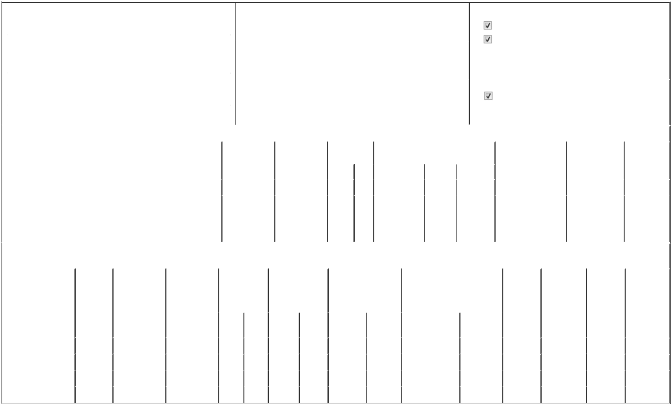

 | 1. Name and Address of Reporting Person* |  |  |  |  |  |  |  |  | 2. Issuer Name and Ticker or Trading Symbol |  |  |  |  |  |  |  |  | 5. Relationship of Reporting Person(s) to Issuer
 |  | REBELEZ DARREN M |  |  |  |  |  |  |  | CASEYS GENERAL STORES INC [ CASY ] |  |  |  |  |  |  |  |  | (Check all applicable)
 |  |  |  |  |  |  |  |  |  |  |  |  |  |  |  |  |  |  |  |  | Director |  |  | 10% Owner
 |  |  |  |  |  |  |  |  |  |  |  |  |  |  |  |  |  |  |  |  | Officer (give title |  |  | Other (specify below)
 |  | (Last) | (First) |  |  | (Middle) |  |  |  |  |  |  |  |  |  |  |  |  |  |  | below)
 |  | (Last) |  |  |  | (Middle) |  |  |  | 3. Date of Earliest Transaction (Month/Day/Year) |  |  |  |  |  |  |  |  |  |  | below)
 |  | (Last) |  |  |  | (Middle) |  |  |  |  |  |  |  |  |  |  |  |  |  |  | President and CEO
 |  | ONE SE CONVENIENCE BOULEVARD |  |  |  |  | 06/04/2026
 | (Street)
 |  |  |  |  |  |  |  |  |  | 4. If Amendment, Date of Original Filed (Month/Day/Year) |  |  |  |  |  |  |  |  | 6. Individual or Joint/Group Filing (Check Applicable Line)
 |  | ANKENY | IA |  |  | 50021
 |  | ANKENY |  |  |  | 50021 |  |  |  |  |  |  |  |  |  |  |  |  |  |  | Form filed by One Reporting Person
 |  |  |  |  |  |  |  |  |  |  |  |  |  |  |  |  |  |  |  |  | Form filed by More than One Reporting Person
 |  | (City) | (State) |  |  | (Zip)
 |  |  |  |  |  | Table I - Non-Derivative Securities Acquired, Disposed of, or Beneficially Owned
 | 1. Title of Security (Instr. 3) |  |  |  |  |  | 2. Transaction |  |  |  | 2A. Deemed |  | 3. Transaction |  | 4. Securities Acquired (A) or Disposed Of |  |  |  |  | 5. Amount of Securities |  |  | 6. Ownership |  | 7. Nature of
 |  |  |  |  |  |  | Date |  |  |  | Execution Date, |  | Code (Instr. 8) |  | (D) (Instr. 3, 4 and 5) |  |  |  |  | Beneficially Owned |  |  | Form: Direct (D) or |  | Indirect
 |  |  |  |  |  |  | (Month/Day/Year) |  |  |  | if any |  |  |  |  |  |  |  |  | Following Reported |  |  | Indirect (I) (Instr. 4) |  | Beneficial
 |  |  |  |  |  |  |  |  |  |  | (Month/Day/Year) |  | Code | V | Amount |  | (A) or (D) | Price |  | Transaction(s) (Instr. 3 |  |  |  |  | Ownership
 |  |  |  |  |  |  |  |  |  |  |  |  |  |  |  |  |  |  |  | and 4) |  |  |  |  | (Instr. 4)
 | Common Stock |  |  |  |  |  |  |  |  |  |  |  |  |  |  |  |  |  |  | 73,715 |  |  |  | D
 |  |  |  |  |  |  |  |  |  |  |  |  |  |  |  |  |  |  |  |  |  |  |  |  | Voting and
 | Common Stock |  |  |  |  |  |  |  |  |  |  |  |  |  |  |  |  |  |  | 535⁽¹⁾ |  |  |  | I | tender
 |  |  |  |  |  |  |  |  |  |  |  |  |  |  |  |  |  |  |  |  |  |  |  | I | rights under
 |  |  |  |  |  |  |  |  |  |  |  |  |  |  |  |  |  |  |  |  |  |  |  |  | 401k plan
 |  |  |  |  |  | Table II - Derivative Securities Acquired, Disposed of, or Beneficially Owned
 |  |  |  |  |  |  | (e.g., puts, calls, warrants, options, convertible securities)
 | 1. Title of Derivative |  | 2. |  | 3. Transaction | 3A. Deemed | 4. Transaction |  |  |  | 5. Number of |  | 6. Date Exercisable and |  |  |  | 7. Title and Amount of Securities |  |  |  | 8. Price of | 9. Number of |  | 10. | 11. Nature of
 | Security (Instr. 3) |  | Conversion |  | Date | Execution Date, | Code (Instr. 8) |  |  |  | Derivative |  | Expiration Date |  |  |  | Underlying Derivative Security |  |  |  | Derivative | derivative |  | Ownership | Indirect
 |  |  | or Exercise |  | (Month/Day/Year) if any |  |  |  |  |  | Securities Acquired |  | (Month/Day/Year) |  |  |  | (Instr. 3 and 4) |  |  |  | Security | Securities |  | Form: | Beneficial
 |  |  | Price of |  |  | (Month/Day/Year) |  |  |  |  | (A) or Disposed of |  |  |  |  |  |  |  |  |  | (Instr. 5) | Beneficially |  | Direct (D) or | Ownership
 |  |  | Derivative |  |  |  |  |  |  |  | (D) (Instr. 3, 4 and |  |  |  |  |  |  |  |  |  |  | Owned |  | Indirect (I) | (Instr. 4)
 |  |  | Security |  |  |  |  |  |  |  | 5) |  |  |  |  |  |  |  |  |  |  | Following |  | (Instr. 4)
 |  |  |  |  |  |  |  |  |  |  |  |  |  |  |  |  |  |  |  |  |  | Reported
 |  |  |  |  |  |  |  |  |  |  |  |  |  |  |  |  |  | Amount or |  |  |  | Transaction(s)
 |  |  |  |  |  |  |  |  |  |  |  |  | Date |  | Expiration |  |  | Number of |  |  |  | (Instr. 4)
 |  |  |  |  |  |  | Code V |  |  |  | (A) | (D) | Exercisable |  | Date |  | Title | Shares
 | Restricted stock units |  | (2) |  | 06/04/2026 |  | A |  |  |  | 3,084 |  | (3) |  | (3) |  | Common Stock | 3,084 |  | $0 |  | 3,084 |  | D
 | Restricted stock units |  | (2) |  |  |  |  |  |  |  |  |  | (4) |  | (4) |  | Common Stock | 5,211 |  |  |  | 5,211 |  | D
 | Restricted stock units |  | (2) |  |  |  |  |  |  |  |  |  | (5) |  | (5) |  | Common Stock | 3,747 |  |  |  | 3,747 |  | D
 | Restricted stock units |  | (2) |  |  |  |  |  |  |  |  |  | (6) |  | (6) |  | Common Stock | 2,422 |  |  |  | 2,422 |  | D

Explanation of Responses:

- Allocated to 401k plan account as of April 30, 2026.

- Each restricted stock unit represents the right to receive, following vesting, one share of Common Stock.

- Pursuant to terms and conditions of 2025 Stock Incentive Plan. This award will vest in equal installments on June 15, 2027, June 15, 2028 and June 15, 2029. Not included in the reported award amount is a target amount of performance-based restricted stock units that will vest on June 15, 2029, but which are subject to the satisfaction of certain performance criteria other than solely the price of Casey's Common Stock; the final amount of shares earned, if any, will be reported upon vest and satisfaction of those performance measures.

- Pursuant to terms and conditions of 2018 Stock Incentive Plan. This award will vest in equal installments on June 15, 2026, June 15, 2027 and June 15, 2028. Not included in the reported award amount is a target amount of performance-based restricted stock units that will vest on June 15, 2028, but which are subject to the satisfaction of certain performance criteria other than solely the price of Casey's Common Stock; the final amount of shares earned, if any, will be reported upon vest and satisfaction of those performance measures.

- Pursuant to the terms and conditions of the 2018 Stock Incentive Plan. The remainder of this award will vest in equal installments on June 15, 2026, and June 15, 2027. Not included in the reported award amount is a target amount of performance-based restricted stock units that will vest on June 15, 2027, but which are subject to the satisfaction of certain performance criteria other than solely the price of Casey's Common Stock; the final amount of shares earned, if any, will be reported upon vest and satisfaction of those performance measures.

- Pursuant to terms and conditions of 2018 Stock Incentive Plan. The remainder of this award will vest on June 15, 2026. Not included in the reported award amount is a target amount of performance-based restricted stock units that will vest on June 15, 2026, but which are subject to the satisfaction of certain performance criteria other than solely the price of Casey's Common Stock; the final amount of shares earned, if any, will be reported upon vest and satisfaction of those performance measures.

Remarks:

Ex. 24 - Power of Attorney

 | Erika Bertrand, under Power of |  |  | 06/08/2026
 | Attorney dated December 11, 2025
 | ** Signature of Reporting Person |  |  | Date
Reminder: Report on a separate line for each class of securities beneficially owned directly or indirectly.
* If the form is filed by more than one reporting person, see Instruction 4 (b)(v).
** Intentional misstatements or omissions of facts constitute Federal Criminal Violations See 18 U.S.C. 1001 and 15 U.S.C. 78ff(a).
Note: File three copies of this Form, one of which must be manually signed. If space is insufficient, see Instruction 6 for procedure.
Persons who respond to the collection of information contained in this form are not required to respond unless the form displays a currently valid OMB Number.



